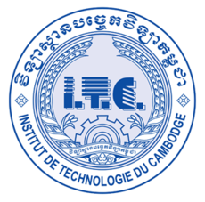ព្រះរាជាណាចក្រកម្ពុជា

ជាតិ​ សាសនា ព្រះមហាក្សត្រ

Institute of technology of Cambodia

Department of Information and communication Engineering

FILE IO IN C++

Project: Algorithm and Programming ll

Lecturer: BOU CHANNA

Student: VEN THON

ID: e20191250

Group: I3-GIC-C

Year: 2022-2023

Problem1:

Product management:

1.Create product

2.Display all product

3.Display a product by ID

4.Update product by ID

5.Delete product by ID

6.Search for a product

Problem2:

Book store management:

1.Create book store

2.Display all book store

3.Display a book store by ID

4.Update book store by ID

5.Delete book store by ID

6.Search for a book store

Problem3:

Number testing:

1.Check if its a primary number

2.Check if its a perfect number

3.Check if its a palindrome number

Problem4:

Basic math:

1.Summation of all numbers

2.Subtraction of all numbers

3.Multiplication of all numbers

4.Division of all numbers

Problem5:

Math suit:

1. 1+2+3+....+n

2. 1+3+5+....+n

3. 1^2+2^2+....+n^2

4.Sum primary 1 to n

Problem6:

Number conversion:

1.Base 2 to 10

2.Base 10 to 2

3.Base 8 to 10

4.Base 10 to 8

5.Base 10 to 16

